Paoer Turret

Jordan Melancon, Peter DiMarco, Channing Maher, and Anthony Sanchez

Advisor: Dr. Kuo-pao Yang

Computer Science and Industrial Technology Department

Southeastern Louisiana University

Hammond, LA 70402 USA

***Abstract*—**

The goal of this project is to create an automated turret that will follow its target and shoot at it. The project will utilize various hardware components to control the turret and software for programming the turrets movement and shooting mechanism. The design of this project will incorporate the use of hardware and software together to control a turret.

***Keywords-***

* Turret, Automated, Pixy, Nerf, Control

# Introduction

Microcontrollers are small computers on an integrated circuit. They are able to control various processes using their own memory and input/output peripherals. Typical applications for microcontrollers are automation, controls, processes, and many devices. The main benefit of using microcontrollers are their size and cost. They are much cheaper for various projects that need fast processing power while still keeping a small scale. This project will utilize a microcontroller for controlling the turrets movement and shooting.

1. Hardware

The Arduino UNO microcontroller is the top choice for this project because it can offer a simple and easy to use hardware component and open-source IDE software for programming. The UNO features a ATmega328P microcontroller clocked at 16MHz which controls the 14 digital and 6 analog I/O pins. It can store code from the Arduino IDE on the 32KB integrated flash memory module which allows it to store large amounts of code. The UNO will be able to handle the operations of this project while providing enough processing power to control the turret. For the autonomous operations, the Arduino will be powered by 5 AA batteries, providing 6V to the UNO.

The turret that is used for this project is a NERF Vulcan EBF-25. This NERF turret was introduced in 2008 and was widely popular among children and quickly became the flagship of the N-Strike series. The Vulcan uses the classic motorized direct plunger design for firing their whistle darts that were produced by NERF in 2003. The turret also introduced a firing belt with a 25-dart capacity. The turret can have a maximum firing rate of 3 darts per second by either an automatic or single-fire mode. The firing range for the turret under normal operation is 25-35 feet. The turret receives power from 6 “D” style batteries that control the firing mechanism.

The NERF turret is mounted on a custom-built platform designed by Jordan and his father. The materials used for the platform are a ¾” 4’x8’ precut oak plywood, ¾” dowel measuring 9” and 4”, marbles, and various hardware such as screws, staples, wood glue, and anchors. The pieces of plywood were measured and cut by hand with a simple design featuring a large base platform for the project to rest on, a rotating and tilt mechanism for the turret, and a smaller platform for the turret to rest on. The anchors are used to secure the turret to the small platform during movement. The design is simple and effective for the project and will provide ample support for the turret.

The ability for the platform to move comes from two independent standard servos. The tilt motion is produced by the Hitec HS-805BB+. This servo is a heavy-duty servo that delivers 343 oz-in of torque which is needed for lifting the weight of the turret. The servo can run on 6V which outputs the maximum amount of torque that is needed for the tilt. The rotation servo is the Bluebird BMS-660DMG. This servo produces 201 oz-in at 6V and can have a maximum voltage of 7.4V.

The turret will be able to follow an object and be able to shoot at it with the control of an image sensor. The image sensor used in this project is the Pixy CMUcam5. This sensor is a programmable image recorder that can sense color in objects and can be taught to follow a certain color. It is able to track multiple objects simultaneously, process that data, and output it to a controller 50 times a second. The filtering algorithm is color-based meaning that it will scan an image and detect color in the image which allows it to follow an object with the same color it was taught. The Pixy uses a NXP LPC4330 processor that can handle large amounts of data while still processing information quickly. It can send data to a number of different microcontrollers using multiple interface such as: UART Serial, USB, SPI, or analog/digital output. The Pixy is compatible with Raspberry Pi, BeagleBone, Arduino, and other microcontrollers. The Pixy is a simple and easy to program sensor that will be useful for the turret to find objects and move to their positions.

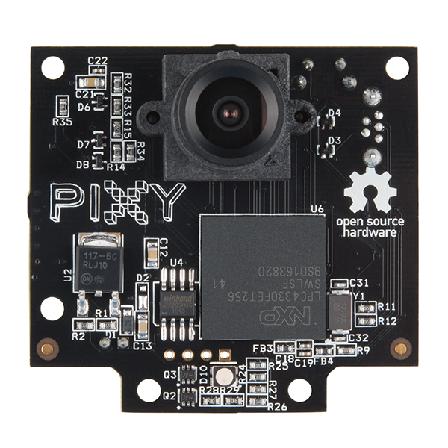

1. Software

Arduino IDE is a software that is used to program the Arduino Uno microcontroller in this project. Arduino IDE makes use of built-in libraries made to help Arduino users control and interact with hardware. Arduino uses a language that is closely related to C language. For this project an imported library for the Pixy Camera was used to analyze the data being set through the Pixy. The IDE can detect different Arduino microcontrollers plugged into the computer via serial usb ports. Different microcontrollers make use of different memories so an option to set the uploaded program to a different model of Arduino is simple. The compiler is a program syntax and error checker for the IDE. Uploading the code is a very easy process, the IDE will compile then upload to the Arduino.

Pixymon is a program designed by the creators of the Pixy Camera. The software allows the users to see what the camera is seeing. There are two options of video output, Raw and Cooked. Raw is without true pictures, it will display the tracking box for items being tracked. Cooked will show a full picture quality allowing the user to exactly see what the Pixy sees. You can also see the trackers in Cooked. Pixymon can change default values of the Pixy Camera. You can change the color sensitivity of signatures for the Pixy, the brightness of the picture, teaching color teaching threshold, brightness of the RGB led displaying the tracked color, name the signatures, the max blocks a tracked object can take up, set minimum blocks tracked, change the servo gain if the Pixy’s servos were directly connected and the signal sent to the servos all with using the Pixymon software. To get started with Pixymon, they include a live demo code for showing how the Pixy will track and follow an object.

# Goals

Our goal is to create an autonomous turret capable of tracking a specific colored object and firing on command. With this in mind, programming a tracking turret would be a great way to exercise our knowledge of microcontrollers. The project will provide us with making full use of a microcontroller’s multity component controls. The turret will use the Pixy Camera to track colored objects. When the turret is centered with a target, it will fire a dart. The firing mechanism makes use of an automated spring loader to automatically reload new darts. The turret will have a pan and tilt motion for tracking, the pan will have a range of 0 to 180 degrees and tilt will have a range of 0 to 45 degrees. The Pixy Camera, firing mechanism and servos controlling the pan/tilt are controlled by an Arduino Uno.

People have done projects like this before, so at first glance this project can seem pretty easy, but we have added our own twist to the project by adding a Pixy Camera. The Pixy Camera will allow us to specify where the turret will point and if the turret is allowed to shoot at it. We also wanted to use different servos with more torque because our design of the platform is unique, and the turret will need more power for rotation and tilt. Our idea of a tracking turret makes use of a more specific tracking. Sure you could place a camera on the turret and track motion, but motion cannot give you accuracy. The turret should track and center its target while also identifying exactly what it is shooting at.

# Related Work

In the past, there have been projects like ours that used different means to control and navigate the servos for the turret. Instead of a Pixy Camera, they used a webcam to recognize facial structures. Though this seems like a great and unique idea for implementation for the purpose of this project, facial recognition can be finicky. Faces can’t be properly detected from long range. Slight change in facial features can cause errors, simply blocking your face can cause readings to go wrong and misidentification can occur if two people were to look the same. Other attempts at this project have made the turret motion detecting remotely controlled and temperature sensitive. Motion detection is great for restricting a large area off limits to everyone, but this can cause false alarms when authorized personnel activate the motion sensor from simply walking through the line of sight. Remote control is a very nice feature allowing the user to freely control the turret and firing, but this comes with its own problems. The turret is no longer capable of tracking without user input, controls can be difficult, range for the remote control can be limited and constant surveillance can be tedious. Temperature sensors are a nice option. They allow the turret to track heat signatures. The turret will be able to tell the difference between a human and an object, but this still has some issues. The temperature in a active room can be constantly changing, and this can mess with the threshold of the sensor causing false readings to occur. Many of these ideas are great and have their purpose, but ultimately, they all have their own downfalls.

Using the Pixy Camera, we have been able to bypass some of the issues these other projects have ran into. Since the Pixy Camera is capable of scanning its view for signature colors, it can pick out colors in a room. This can make detecting a target easier. The range of the turret depends on the size of the target’s color, so small distant objects may not be detected. The camera is easily programmed with servos to track its target, so it makes it user friendly. Code for the Pixy is easily available on most popular microcontrollers, and since the Pixy can store its own values, no additional work will be needed by the user. The Pixy downfalls include being able to track similar colors and not being able to focus on one color. It also does not have the highest quality video output and focusing the Pixy can be tedious when focusing on father objects.

The Pixy Camera was coded to center itself with the current object it was tracking. Since the Pixy could not be mounted, we decided to set the Pixy in a position that would auto center the turret with the tracked target. The specifics of how the camera works must first be explained to describe how the camera decides if it needs to move. When an image is scanned on the Pixy, each pixel displayed acts as a box. This box is what is used to determine what color is present. When a targeted color is present, the box is outlined. When a grouping of boxes occurs then the camera knows that the large group is a object. Now, if the object was to move in the front far left of the camera, naturally the camera would follow to center the grouping of boxes. The movement of the camera’s servos works both up down and left to right. It's also noted that the farther the object is, the less movement is need by the servos. The object becomes smaller while the distance increases between the camera and the object.

The servos we chose took some time to figure out the best settings for them. Without the weight of the gun, the mount moved freely and with ease. But once the gun was added, the tilt for the turret had some difficulties. The problem we had and fixed was that the servos did not have enough torque to the tilting piece. Once the piece was redone and the power was amplified, the tilt servo moved the turret with ease. The mount that was designed by Jordan and his father was a great design. Other design would have required a linear actuator which would have been too slow for our current design.

Camera mounting has been a common quality for each related project we have seen. We thought of mounting the camera to the gun but could not find an accurate spot for the camera to accurately control the turret to point to an object. If we were to mount the camera on the gun just like other projects, the guns spastic movements will confuse the Pixy. This could damage the camera, gun, or mount if allowed to thrash around. For the tradeoff of tracking realism, we went for limited accuracy. This has been found to make the gun aim smoother. For this purpose, this setup was a great idea.

With this information being said, the Pixy is still a much more effective option for this project. We do not demand extremely long range with this project and the turret will track one target at a time. Since the Pixy is stationary on the mount, the camera focus is of no concern. For our purpose, the Pixy was the right choice is every aspect.

# Implementation

## Software Approach and Implementation

The programming for the turret used libraries provided by both Arduino’s and Pixy’s website. The Arduino’s library we used is the servo library. It contains methods made to control various servos. Usually a servo would need to be controlled with a loop of HIGH and LOW signals that repeat through a delay. The higher the delay, the slower the movement of the servo. The servo library makes this system all into one simple library that makes use of the pulse modulation pin the servo is connected to. Most simple HIGH and LOW signals make use of standard digital I/O, but the servo needs a pulse modulation signal to function properly in the code.

The servo library is called in the Arduino IDE with the line #include <Servo.h>, when this line is applied to the code, the user gains full access to all of the methods included in the library. Some methods available include (Servo refVal;) this line initiates a servo value. This value can then be called to a pin on the Arduino with (refVal.attach(pin #) ;). This line will allow the refVal to carry the pin number needed for the servo to function. Since the servo has its own range of movement, we will need to use a map function to set values being used to control the servo to usable ranges. This is a built-in function that doesn’t need to be called from a library. The map function looks like this (assigning refVal = map (current refVal, minrefVal, maxrefVal, newminrefVal, newmaxrefVal;). This is a extremely useful function for setting ranges for controlling values. The controlling values in our case is the Pixy Camera sending signals to move to the center of view for the color being targeted. Since we have a controlling value now that can be used by the servo, we use a write function. This is a built-in function that does not need a library to call. The function is set up like this(refVal.write(controlrefVal);). When this function is inputted, the servo will have a location to move to. The map and write lines are all written in the loop of the the Arduino method so that they constantly loop, will will make use of this since the servo will always have new values being sent to it. A delay will be necessary at the end of the loop, but we cannot have the servo instantly taking in new movement values. The servo will simply not register those movements in time.

Since we are adding the Arduino library for the servo, we can add the Pixy and SPI as well. The Pixy Camera library can be included by having #include <Pixy.h>, with this line you gain access to the Pixy Cameras full library. This library includes methods to locate the current location of a tracked object, the signature of the object assigned, the current angle of the camera and a print method used to see the current values of x,y, height, and width of a tracked object. With the Pixy camera library usable, we can use a data type (uint16_t) this is a data type that we gain access to by including the SPI library with. This library can be included with #include <SPI.h>. This allows us to access the Arduino’s SPI pins, these are connected to the Pixy Camera’s data pins located on the back of the camera. This directly allows the pixy to send usable data to the Arduino. We assign a data type for the pixy with (uint16_t refVal;). Now we can use this reference value to access the information form the Pixy. The Pixy will need to also be accessed with the Pixy function. This can be done with (Pixy refVal;), this allows us to refer to the Pixy hardware for updates. You will still need to initialize the Pixy with the line (pixy.init();). Once the Pixy is set up, you can run the pixy through the loop method. You will initialize the scanning of the “blocks” of the Pixy Camera. This scans the view of the Pixy for a signature value assigned to be tracked. You will use this function to accomplish it: (refBlock = refPixy.getBlocks();). Once this is scanned, you will not want the code to run unless the Pixy detects an object to track. You will set an if statement to check for blocks in range of the Pixy. Once you are scanning for blocks, you will want the servos to move to the range determined by the Pixy Camera. To gain access to these coordinates you will use both the (refPixy,refBlocks[].x) and (refPixy.refBlocks[].y). These lines will gain you access to the x and y coordinates of the object being tracked on the Pixy Camera. X has a current range of 0 to 319 and Y the range of 0 to 199. You will want to use a map function to set these values to usable values for your servo. Since the code is in a loop, it will constantly be scanning the Pixy for updates on the location of the object. This will have the servos constantly changing their current values.

For the firing control of the gun, we needed to be able to press the push button at any given time to fire the gun without interfering with the servo controls. To do this, we implemented a hardware interrupt. An interrupt is a function one can call on at any point in the code. This function will activate without stopping any current processes happening. To do this, one would call an attach interrupt line in the setup. The way that works is that the user initializes a pin creating the interrupt and the function that will be called when activated. For our purpose we used the push button as the interrupt pin. This push button would activate pin 4 on the Arduino which turned on the firing control.

Another part of the firing control we needed to implement was a software debounce on the push button. Normally a push button can be pressed once however, it will trigger multiple times. to prevent this, we setup a millis function. This would check when the button is pressed by seeing at what time it was activated in the program. If that time exceeds more than the debounced time, than the button can be triggered again. For our purposes using 200 milliseconds was more than enough time to not receive multiple hits.

## Hardware Approach, Equipment, and Programming

The Nerf Vulcan gun needed to be properly mounted to a system that would allow the gun to freely move without obstruction. For our mounting system, we decided to go with a heavy-duty material such as wood. It would be able to hold the weight of the gun and move with ease. To do so, we created a rectangle base which would house our electronic components and batteries safely and out of harm's way from the moving gun, but in a position where we could still access it to work on it. For the pan movement, we used a wooden dowel that would turn using the Bluebird BMS-660DMG servo. This servo allows for fast 0 to 180-degree movements but also has enough torque to move the gun. To aid in the rotation movement, a ball bearing ring was needed. However, we could not quite find one that would work so we instead improvised and created our own ball bearing ring. We also designed this mechanism with a square wooden board with holes drilled in a circular pattern along a circle. In these holes, marbles were used as friction assistance to glide the wooden plate allowing the servo to pan the gun.

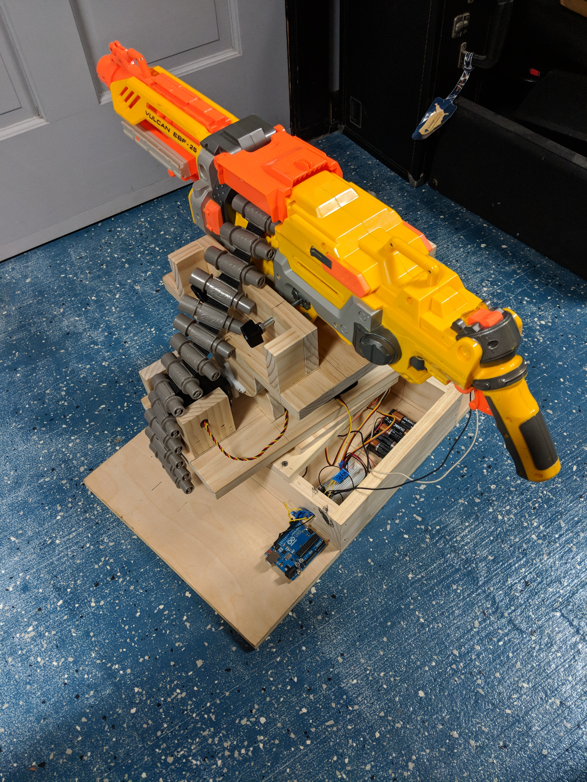

For the tilt axis of the gun, we used another wooden dowel that would run across two wooden semi circles that are mounted to the rotating base. At the end of one of the rotating bases is the mount for our second servo, the Hitec HS-805BB+. This is a monster of a servo motor as it allows for an incredible amount of torque. This would be more than enough to have power to tilt the large Nerf gun back and forth. This servo motor would tilt a wooden platform, which is a flat surface area with sides to hug the gun. Next was the anchoring of the Nerf gun to the tilting wooden platform. We used four large screws with handles at one end to tighten through an opening in the wood with a bolt. This would press directly against the gun with enough force to keep the gun in place.

Our last obstruction before wiring our turret up was the firing control. The way the nerf gun works is that an on button is flipped to power on, and the user pulls the trigger allowing for a rapid succession of bullets. For our use we did not need to pull the trigger as the gun would be controlled via the Arduino using the push button. So to bypass this we took apart the gun completely down to the bare parts. We had found the series circuit for the gun wiring. We were able to solder another wire in parallel to the existing one running from the trigger to the power button of the gun. This would allow us a clear circuit to control the gun using other electronic components. While the gun was also apart, we soldered wires to run to the battery compartment so that we could place the overly heavy battery box in our gun mount base, freeing up a lot of weight from the gun.

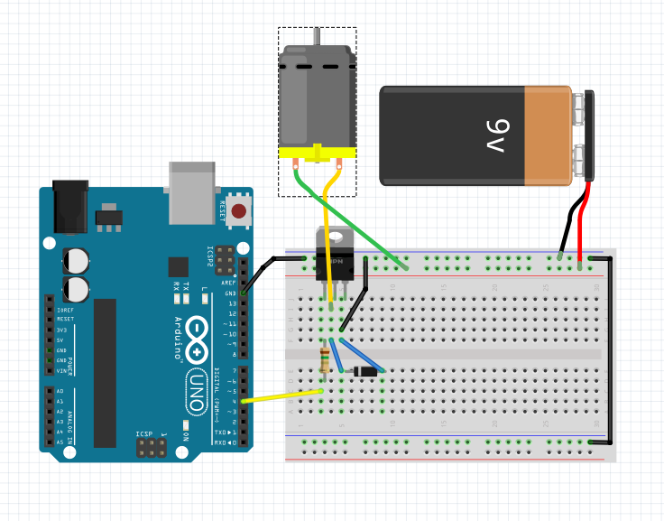

As for our circuit design, there are two coinciding circuits to run our Nerf turret. One is the firing mechanism while the other is the servo motor control and Pixy camera system. To begin with our firing circuit, we used an assortment of electronic components such as a TIP120 transistor, a 1N4001 diode, a 1K Ohm resistor, a 10K Ohm resistor, and a push button. The overall way our firing circuit works is that without the push button being pressed, the gun will not fire even if the trigger is pulled. After the button is pressed, the Arduino will send a signal to the transistor which will activate the transistor to allow for current flow from the gun’s battery box to the gun itself. This will activate the firing mechanism and the gun will begin to fire until the button is pressed again. The diode is put in place to not allow for current to flow backwards, and the resistors are put in place to protect the Arduino and push buttons. For the wiring we first started off with the transistor. A transistor is an electronic component that with the right setup can be used as a switch which is our use for it. The transistor has 3 pins, base, collector, and emitter. For the base of the transistor we wired a line to pin 4 on the Arduino with a 1K Ohm resistor. For the collector, the ground connection from the gun’s motor. Then the emitter has a wire running to the common ground of the Arduino. Also, on the emitter line, the diode is placed running back into the collector pin. This is so the current does not feedback into the transistor and fry the gun’s motor. For the power delivery to the firing control we used the battery box that was previously mounted inside the gun. The ground of the battery box was wired to our common ground and the lead wire was ran directly into the gun’s motor as it is the only thing being powered by the battery box. Then for the push button to control the firing there are 4 pins. On one side of the push button, a lead wire is sent directly to the Arduino’s 5V pin to power the button. The pin adjacent to it is wired to the ground with a 10K Ohm resistor. On the pin opposite to the ground a wire is sent to pin 2 on the Arduino. We needed to specifically send it to pin 2 because we programmed the push button as an interrupt so that we can fire the gun at any time while the servos are moving.

The other circuit we needed to set up was the servo motor control. For each of the servo motors there are 3 wires, one lead, one ground, and a control signal. We connected the lead and ground to their own power supply as the Arduino does not have enough current to run them, and our other power supply is strictly for the gun. For the control signals they are ran directly into the Arduino’s pins 3 and 5.

# Evaluation

Originally before using the Pixy camera we implemented a joystick controller to move the turret servo motors. We designed this by using two joysticks attached to a breadboard. To wire our controller back to the Arduino we used wire extensions so that we could use the controller at a distance. This setup provided optimal performance due to the ease of use of tactile controls over automating the turret.

We also in the beginning had trouble getting the turret with the gun attached to properly tilt up and down. With the gun attached, the turret mount would get stuck at certain positions causing the servo motors to fail. To compensate for this, we redesigned the tilt mount on the turret to pivot at a lower point to allow for a more centered point of tilt. This improved designed also helped with another issue we were having which was the gun hitting the table we placed it on. If the joystick was pressed to the extreme up or down position the gun would slam into the table. Since we moved the tilt mount lower to the frame however, this prevented the gun from reach as far forward and back as it was. This allowed for us to fix two problems with one being unintentional.

# Conclusion and Future Work

The main purpose of this project was to create a turret capable of tracking a target without remote use and have the turret fire rounds at selected target. This was all needing to be done on an Arduino Uno with the Arduino IDE software to program the microcontroller. The Pixy Camera was the best option for making a tracking turret.

Knowing that we would need to control multiple devices at once, the Arduino Uno was our best option. Since the Arduino Uno has been the go to choice for microcontrols in our classes and we all have plenty of experience working with Arduino controllers in the past.

For tracking, we found the Pixy Camera to be perfect for what we were going to use it for. The Pixy Camera can easily detect colors, so we decided to make the turret a color-based tracking system. The turret would only need a bright basic color to track. This would make the tracking fairly easy to distinguish from background colors.

For the actual movement of the turret, we decided on using two different servos for the pan and tilt of the turret. The tilt servo is a Hitec HS-805BB+, this servo is much more powerful than the servo used for pan. The tilt servo had to have enough force to pull the mounted gun backwards and forward.

For the pan we decided on the, Bluebird BMS-660DMG. This servo is less powerful than the tilt servo, this is because of the design for the mount. The mounts uses a ball-bearing set up creating less stress on the servo.

The original idea for the project was fairly simple in thought, but after having the hardware, problems began to arise. Using two servos controlled by one Arduino is not possible without an external battery but having enough voltage for just the servos were not the only problem. The Pixy Camera needs it’s on power source, even while connected through the ISP of the Arduino.

We were capable of solving the power issue by supplying power to each servo separately. And the Pixy Camera uses a external battery to supply enough power to operate its logic. This has shown to solve the issues with power.

##### References

* Instructables. “Nerf Vulcan Sentry Gun.” *Instructables.com*, Instructables, 24 Oct. 2017, [www.instructables.com/id/Nerf-Vulcan-Sentry-Gun/](http://www.instructables.com/id/Nerf-Vulcan-Sentry-Gun/)
* Prochnow, Dave. “Defend Your Cubicle With A Nerf Sentry Gun.” *Popular Science*, 14 May 2014, [www.popsci.com/article/gadgets/defend-your-cubicle-nerf-sentry-gun](http://www.popsci.com/article/gadgets/defend-your-cubicle-nerf-sentry-gun)
* “Pixy (CMUcam5) – Charmed Labs.” *CharmedLabs*, charmedlabs.com/default/pixy-cmucam5/
* Arduino Debounce. (2015, July 29). Retrieved from <https://www.arduino.cc/en/Tutorial/Debounce>
* Transistor Motor Control. (n.d.). Retrieved from <https://www.arduino.cc/en/Tutorial/TransistorMotorControl>
* Monk, S. (2012, December 17). Arduino Lesson 13. DC Motors. Retrieved from <https://learn.adafruit.com/adafruit-arduino-lesson-13-dc-motors/transistors>
* AttachInterrupt(). (n.d.). Retrieved from <https://www.arduino.cc/reference/en/language/functions/external-interrupts/attachinterrupt/>
* Cuartielles, D. (n.d.). Arduino Joystick. Retrieved from <https://www.arduino.cc/en/Tutorial/JoyStick>
* SPI. (n.d.). Retrieved from <https://www.arduino.cc/en/Reference/SPI>
* Components. (n.d.). Retrieved from https://playground.arduino.cc/Main/Components

##### BIOGRAPHY



Jordan Melancon has attended Southeastern since fall of 2014 and plans to graduate with a degree in Engineering Technology with a concentration in computer in spring 2018. When not studying computer engineering, Jordan enjoys playing guitar, video games, and hiking.



Peter Dimarco has attended Southeastern since Fall of 2014 and plans to graduate with a degree in Engineering Technology with a concentration in computer in spring 2018. When not studying computer engineering, Peter enjoys building computer, fishing on the weekends, and playing video games.



Channing Maher has attended Southeastern since Fall of 2016 and plans to graduate with a degree in Engineering Technology with a concentration in computer in Fall 2018. When not studying computer engineering, Channing enjoys playing video games, taking care of his dogs, learning different programming languages, and watching scary movies.



Anthony Sanchez has attended Southeastern since Fall of 2015 and plans to graduate with a degree in Engineering Technology with a concentration in computer in Spring 2019. When not studying computer engineering, Anthony enjoys playing video games, weight lifting, sleeping, and watching basketball.